SQL PROJECT

CREATE TABLE Sales ( sale_id INT PRIMARY KEY, product_id INT, quantity_sold INT, sale_date DATE, total_price DECIMAL(10, 2), FOREIGN KEY (product_id) REFERENCES Products(product_id) );

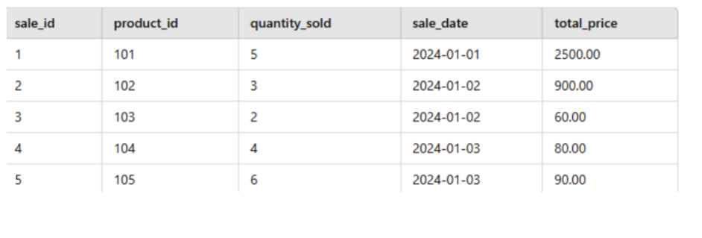
INSERT INTO Sales (sale_id, product_id, quantity_sold, sale_date, total_price) VALUES (1, 101, 5, '2024-01-01', 2500.00), (2, 102, 3, '2024-01-02', 900.00), (3, 103, 2, '2024-01-02', 60.00), (4, 104, 4, '2024-01-03', 80.00), (5, 105, 6, '2024-01-03', 90.00);

CREATE TABLE Products ( product_id INT PRIMARY KEY, product_name VARCHAR(100), category VARCHAR(50), unit_price DECIMAL(10, 2) );

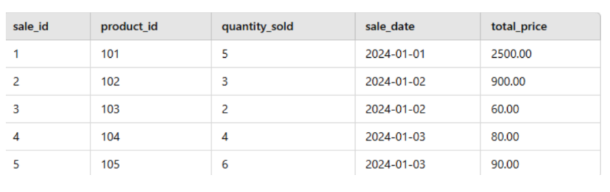
INSERT INTO Products (product_id, product_name, category, unit_price) VALUES (101, 'Laptop', 'Electronics', 500.00), (102, 'Smartphone', 'Electronics', 300.00), (103, 'Headphones', 'Electronics', 30.00), (104, 'Keyboard', 'Electronics', 20.00), (105, 'Mouse', 'Electronics', 15.00);

Q1. Retrieve the product_name and total_price from the Sales table, calculating the total_price as quantity_sold multiplied by unit_price.
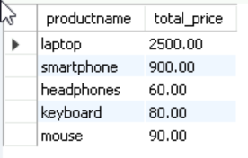

Q2. Identify the Most Frequently Sold Product from Sales table
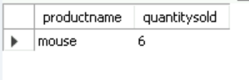

Q3. Find the Products Not Sold from Products table
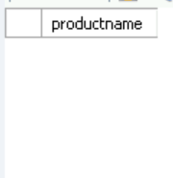
Q4. Calculate the total revenue generated from sales for each product category.
